Mechatronics System Integration (MCTA3203)
Week 5: L298P Motor Driver Shield and relay module
Controlling a 12V DC Linear Actuator using L298P Motor Driver and Relay
Table of contents
- Experiment 1: Control DC Linear Actuator using L298P motor driver
- Task 1
- Experiment 2: Control DC Linear Actuator using 2-way channel relay
- Task 2

Experiment 1: Control DC Linear Actuator using L298P motor driver
Objectives
- To understand the working of the L298P motor driver shield.
- To control the speed and direction of a DC linear actuator using GPIO pins.
- To implement PWM (Pulse Width Modulation) for speed control.

1. Required Hardware
- Arduino UNO
- L298P Motor Driver Shield
- DC 12V Linear Actuator
- Variable Power Supply or 12V Power Supply
- Jumper Wires
- Breadboard

2. Theory
The L298P is a versatile motor driver shield capable of managing two independent DC motor channels. It is designed to handle a voltage range of 4.8V to 24V, supporting a continuous current of 1.0A per channel (with the ability to handle brief peaks up to 2.0A).

- Dual-Channel Control: You can control the speed and direction of two separate motors independently.
- Parallel Wiring: If you are building a 4-wheel drive robot, you can pair the motors on each side to a single channel. This ensures both wheels on one side move at the identical speed and direction while staying within the 2A limit.
- Simplified Directional Logic: Unlike standard L298N modules that require two pins per motor for direction, this shield uses built-in inverters. This saves Arduino pins by using a single "High/Low" signal to flip polarity. While this removes the "active braking" feature, you can still stop the motors effectively by setting the speed (PWM) to zero.
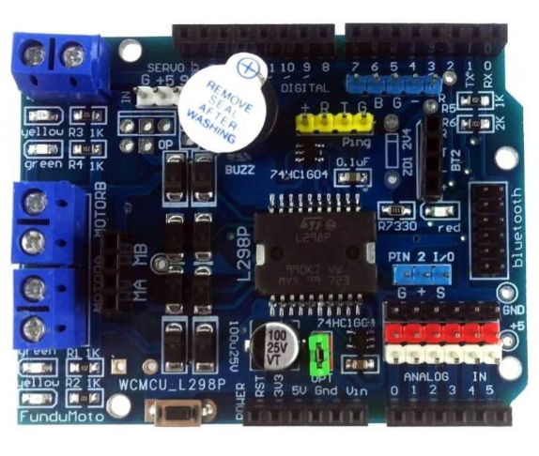
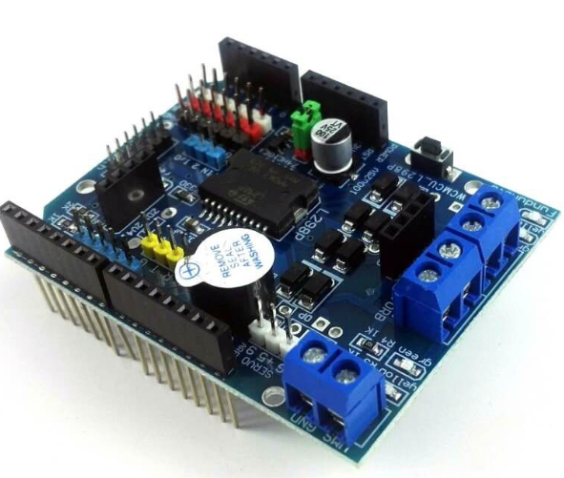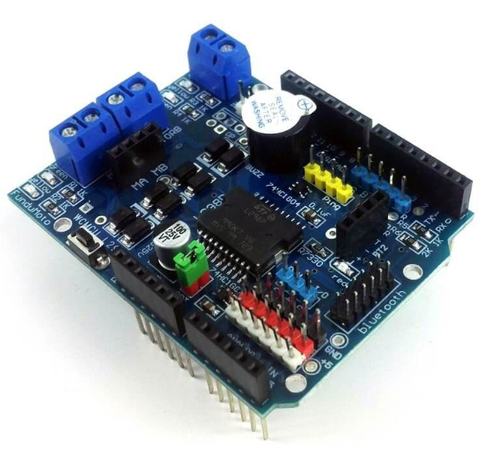

Figure 1 shows the pictures of the L298P motor driver from Cytron technologies

Component | Arduino Pin | Function | Description
Motor A Speed | D10 | PWM | Controls velocity via Pulse Width Modulation (0–255).
Motor B Speed | D11 | PWM | Controls velocity via Pulse Width Modulation (0–255).
Motor A Direction | D12 | Digital | HIGH = Forward / LOW = Backward (Inverted logic).
Motor B Direction | D13 | Digital | HIGH = Forward / LOW = Backward (Inverted logic).

- How Does PWM Control Speed?
PWM (Pulse Width Modulation) is a technique that switches the motor's power ON and OFF rapidly at a high frequency (usually hundreds to thousands of times per second). By adjusting the duty cycle — the percentage of time the signal is ON — we control how much average voltage is delivered to the motor.

Duty Cycle (%) | ON Time | OFF Time | Effect on Speed
0% | 0% | 100% | Motor OFF
50% | Half | Half | Medium Speed
100% | Full | 0% | Full Speed

This average voltage determines the motor's speed:
- Higher duty cycle → higher average voltage → faster rotation
- Lower duty cycle → lower average voltage → slower rotation

3. Circuit Diagram

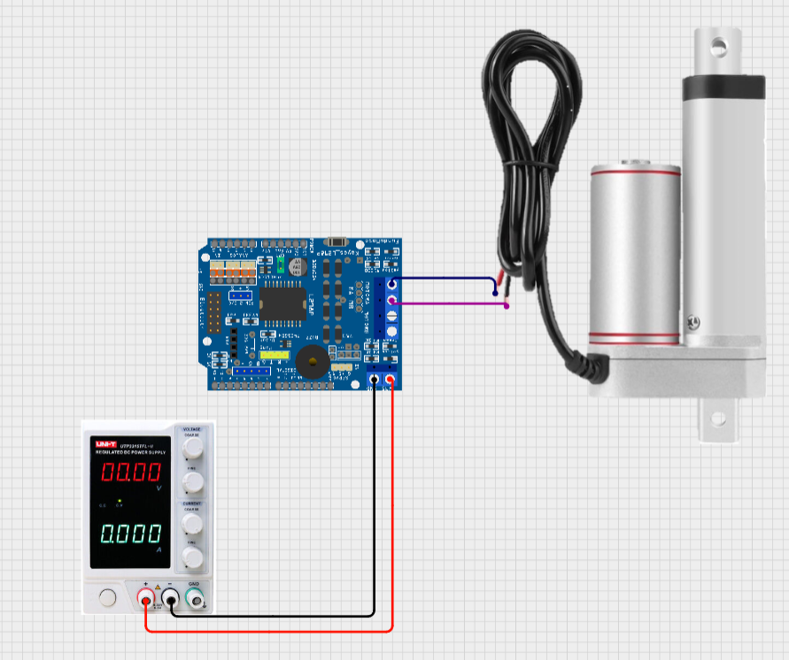

Figure 2 shows the pictures of the L298P motor driver connected to the variable power supply and 12 VDC linear actuator (Created from CirkitDesigner)

Experiment Steps
- Interface the Arduino UNO with the L298P Motor Driver Shield, ensuring all headers are correctly aligned to prevent pin displacement.
- Insert the code and ensure that the Arduino UNO always receive power from the USB.
- Connect the terminals of the 12VDC Linear Actuator to the Motor A (MA) output screw terminals. Ensure the connections are mechanically secure to minimize contact resistance.
- Remove the OPT jumper from the L298P shield. This action breaks the common VCC rail between the Arduino and the motor driver, isolating the high-current inductive load from the logic circuitry and preventing back-EMF or overcurrent from damaging the USB port.
- Connect the Variable DC Power Supply to the VMS (Motor Power) and GND terminals on the shield. Make sure that the VMS is connected to the positive side and the GND is connected to the negative side.
- Set the output voltage to a constant 12V DC. Set the current limit (CC mode) to 3.0A. If the bench supply is rated lower, set it to its maximum rated current.
- Turn on the Variable DC Power Supply and observe the linear actuator retracting or extend. To reverse the side of the linear actuator, reverse the polarity wire of linear actuator.

4. Arduino Code Example
const int ENA = 10; // Control speed of motor A
const int INA = 12; // Control direction of motor A

void setup()
{
pinMode(ENA, OUTPUT);
pinMode(INA, OUTPUT);
}

void loop()
{
digitalWrite(INA, LOW);
analogWrite(ENA, 150);
delay(3000);
digitalWrite(INA, HIGH);
analogWrite(ENA, 150);
delay(3000);
}

⚠️ Safety Precautions
- Remember to remove the OPT jumper first
- Always double-check wiring before powering the circuit.
- Disconnect power before making changes.

Task 1

- Explain the usage of PWM in this experiment.
- Without using the L298P motor driver, make the linear actuator connection using 4 switches with the understanding of H-bridge.

Experiment 2: Control DC Linear Actuator using 2 Way Channel Relay
Objectives
- To understand the working principle of relay
- To control the direction of motor movement using the relay

1. Required Hardware
- Arduino UNO
- 2 Way Channel Relay
- DC 12V Linear Actuator
- Variable Power Supply or 12V Power Supply
- Jumper Wires
- Breadboard

2. Theory
A 2-channel relay module serves as a dual-path electromechanical interface designed to facilitate the control of two independent, high-power circuits via low-power microcontroller signals. Each discrete channel operates as an isolated switch, triggered by digital logic—typically active-low or active-high—sent to the IN1 and IN2 input pins. This architecture allows a low-voltage controller, such as an Arduino or ESP32, to safely manage the switching of high-current DC or AC loads by galvanically isolating the sensitive logic circuitry from the power electronics.

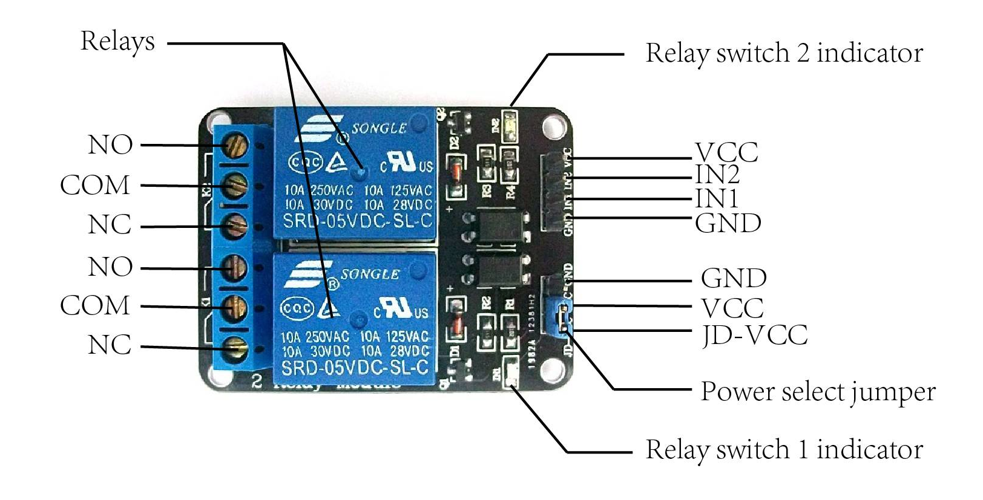
Figure 3 shows the pictures of the 2 Way Channel Relay

The switching mechanism for each channel is defined by three primary contacts: Normally Open (NO), Normally Closed (NC), and Common (COM). In its quiescent or de-energized state, the COM terminal maintains continuity with the NC contact while remaining electrically isolated from the NO contact. Upon activation by the input signal, the internal electromagnetic coil shifts the armature, establishing a low-resistance path between the COM and NO terminals to complete the circuit. This transition simultaneously breaks the connection to the NC terminal, providing a reliable method for toggling power states or reversing polarity in motor applications.

3. Circuit Diagram

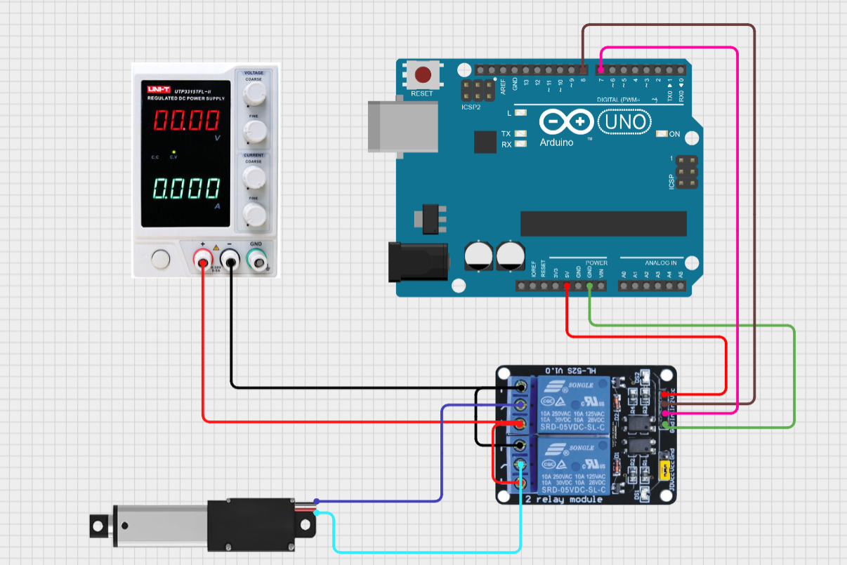

Figure 4 shows the pictures of the 12 VDC Linear Actuator connected to the 2 Way Channel Relay and Variable Power Supply Unit (Created from CirkitDesigner)

Experiment Steps
- Interface the Arduino UNO with the 2-way Channel Relay.
- Bridge the NC (Normally Close) pin and the NO (Normally Open) pin.
- Connect the + terminal of the Variable Power Supply to the NO (Normally Open) pin and – terminal to the NC (Normally Close) pin.
- Connect the 12VDC linear actuator to the COM (Common) pin on the relay.
- Set the output voltage to a constant 12V DC. Set the current limit (CC mode) to 3.0A. If the bench supply is rated lower, set it to its maximum rated current.
- Turn on the Variable DC Power Supply and observe the linear actuator retracting and extend.

4. Arduino Code Example
const int relay1 = 7;
const int relay1 = 8;

void setup()
{
pinMode(relay1, OUTPUT);
pinMode(relay2, OUTPUT);
}
void loop()
{
extendActuator();
delay(5000);
retractActuator();
delay(5000);
}

void extendActuator()
{
digitalWrite(relay1,HIGH);
digitalWrite(relay2,LOW);
}

void retractActuator()
{
digitalWrite(relay1,LOW);
digitalWrite(relay2,HIGH);
}

⚠️ Safety Precautions
- Always double-check wiring before powering the circuit.
- Disconnect power before making changes.

Task 2

- Integrate any sensor into the circuit so that when it detects the actuator to a certain point it will activate an LED light and stop the linear actuator

Appendix

References

- https://www.instructables.com/Tutorial-for-L298-2Amp-Motor-Driver-Shield-for-Ard/
Tutorial for L298 2Amp Motor Driver Shield for Arduino
- https://github.com/CytronTechnologies/L298P_MotorDriverShield
L298P_MotorDriverShield
- https://my.cytron.io/p-shield-l298p-motor-driver-with-gpio?r=1
Shield L298P Motor Driver with GPIO
- https://docs.cirkitdesigner.com/component/a25f6e70-294e-42fd-b77c-9e9349b76b9a/l298p-drive-shield
How to Use L298P drive shield: Examples, Pinouts, and Specs
[5] https://my.cytron.io/p-2-channel-dc-5v-relay-module

